Mill Bay Nature School
At Mill Bay Nature School we are like a C.E.D.A.R.

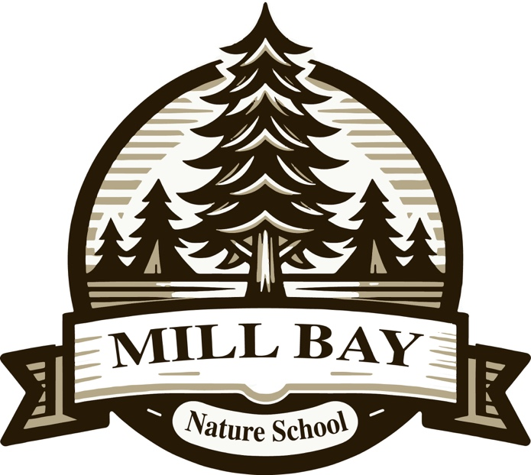

We believe in Community, Empathy, Diversity, Accountability, Respect

Code of Conduct
Educative, Preventative, and Restorative
2025-2026


Code of Conduct

Mill Bay Nature School’s Code of Conduct is in alignment with the Cowichan Valley School District policies and procedures, specifically AP 104: District Code of Conduct, Policy 25: Identity, Belonging and Connection and Safer Schools Provincial Standards for Codes of Conduct Ministerial Order. As per the Ministerial Order, all Cowichan Valley Schools’ Codes of Conduct have at their core, the intention to be educative, preventative, and restorative in practice and response. The Code of Conduct exists to help make the school a safe, caring, and orderly environment for learning and working.

Educative, Preventative, and Restorative
The severity and frequency of unacceptable conduct, as well as rising expectations for behaviour as students grow and mature, will be considered. Whenever possible, responses will be educative, preventative, and restorative, rather than punitive. Students, as often as possible, will be encouraged to participate in the development of meaningful outcomes to promote learning and growth. The primary function of addressing student conduct will be to correct, educate, and develop positive, contributing members of the school community.

Educative | Preventative | Restorative
Providing learning opportunities to understand and reflect on how their actions have impacts. | Proactively creating conditions that keep undesirable actions from happening. | Supporting students to participate in repairing, rebuilding, reinstating,  and redressing relationships.

- Statement of Purpose

All members of Mill Bay Nature School’s community will treat each other with consideration and respect. Our school fosters a safe and caring environment where everyone has the right to enjoy the programs and activities that take place at our school. This means that we will not tolerate fighting, bullying, intimidation, or abusive behaviour. Students and adults work together with each other to build respectful and courteous relationships. The B.C. Human Rights Code prohibits discrimination based on an individual’s race, colour, or sexual orientation. Our school is a safe place students and staff are free from harm, where clear expectations of acceptable behaviour taught, held and met. We all belong here. Publishing, issuing, or displaying any statement, publication, notice, sign, symbol, emblem, or other representation that indicates discrimination or an intent to discriminate against a person or group to hatred or contempt will not be tolerated. We teach and model to all students, positive and respectful behaviour. They are provided with expectations, problem solving strategies and open communication to support them in their day-to-day interactions with each other and staff. The behavioural guidelines at Mill Bay Nature School are based in the following values:
Community
Empathy
Diversity
Accountability
Respect

At Mill Bay Nature School, we are like a CEDAR. The values of the CEDAR are taught, reviewed, and reinforced continuously throughout the year. The grid on the following page outlines some specific details about what it looks like to be like the CEDAR here at Mill Bay Nature School. These expectations and values apply both while at school, as well as during off-school activities such as field trips.

- Acceptable Student Conduct

 | Community | Empathy | Diversity | Accountability | Respect
Inside learning spaces and hallways. | * I can work together to keep the learning spaces and hallways clean. | * I will help others when they need it.  * I can support others or ask for support for others when they are upset. | * I understand that "fair" is not always "equal".  * I am curious and open to people and the differences we may have. | * I take care of my things:  - my space  - my belongings  - my actions | * I will help keep our learning areas safe and clean by:  - keeping my belongings organized  - putting garbage/recycling in proper bins  - using kind and respectful language
Playground and play areas | * I understand that everyone is welcome on the playground and in all play areas.  * I understand we must take turns when there are others wanting to play on the same equipment as me. | * I am kind to others while we play in the same space.  * I can help someone that is hurt or needs support. | * I include others on the playground and in games.  * I understand that everyone has different levels and ways to play. | * I understand and will stay within the play area boundaries.  * I understand that I cannot use physical actions on others (punching, kicking, hitting, spitting, etc.).  * I can own my part and help solve problems when they come up. | * I can problem-solve with others when there is a conflict with help from an adult.  * I use kind words when talking to others.  * I pick up garbage from the playground when I drop it.
Bathrooms | * I keep the bathroom space clean.  * I leave the washroom area when I'm finished. | * I am aware of how other students might be feeling in this space. | * I am aware that everyone has a right to feel safe in the bathroom and that I will ask for help if I need it. | *I will use the bathroom alone; others should not be in the stall with me.  * I will clean up after myself when I am finished using the bathroom. | * I will use the bathroom on my own and respect others when they use the bathroom.  * I understand that everyone deserves privacy when they use the bathroom.
Garden and natural spaces | * I understand that the garden area is a learning space, and we work together to keep it healthy. | * I understand that the garden and natural spaces are living things. I am gentle and kind in these areas. | * I will be kind and respectful to others and their needs in the natural spaces. | * I understand that the plants are not to be ripped, picked or broken off to play with.  * I will use natural items that are already on the ground to play. | * I understand that the garden needs to be cared for and not to be played in.  * I will be curious but not careless with the different species plants and animals that live in this space.
Rising Expectations
As students grow older and more mature, it is our expectation that they will be held to a progressively higher standard of personal responsibility and self-discipline. As such students will accept increasing consequences for inappropriate behaviour.

Consequences of Unacceptable Conduct
Consequences have the following expectations:
- Responses to unacceptable conduct will be consistent, and equitable, based on individual student needs.
- Wherever possible, consequences will be educative, preventative, and restorative, rather than punitive or disciplinary.
- As often as possible, students will be encouraged to participate in and have a voice in the development of meaningful consequences for violations of the code of conduct.
- We will always consider culturally appropriate and/or culturally sensitive approaches to conduct and consequences of conduct.
Steps to Address Unacceptable Conduct:
- Notification:
- Parents and Caregivers will be notified if a student has gone through communication and problem-solving steps with administration, teachers and/or other staff members and the behaviour or conflict continues to happen. Notification to Parents and Caregivers is to ensure they are aware of the behaviour and are a part of the problem-solving strategies that will be needed to ensure the success in alleviating the behaviors that are happening.
- Parents and Caregivers will be notified if a student has been physically aggressive with others or if police or other agencies (fire, EMT, etc..) involvement was necessary and will be asked to schedule a meeting with administration and/or teachers to move forward with a preventative plan for retaliation.
- Prevention of retaliation:
- Staff will work with student and Parents and Caregivers to create support plans around preventative behaviour. These plans will be approved and followed through by school/district staff and reviewed, updated and communicated on multiple times throughout the year.

Student Suspension
Suspension is one of many strategies in a complex problem-solving restorative process designed to support the student to address unacceptable conduct. Student suspension may be employed as part of the larger intervention process, which will be educative, preventative, and restorative. A parent or guardian, and the Associate Superintendent, will always be notified by the administration in the case of a student suspension.

Personal Digital Devices
Students have no need to use cell phones while on school property. Our school is equipped with the technology needed for instructional learning and teaching. The use of personal devices in school are highly distracting for all students and take away from key learning opportunities. We request that if students need to communicate with parents/guardians, they use the office phone. If for some personal reason, your child needs to take a cell phone to school for after-school use, please remind your child that the device needs to be either submitted to the care of their teacher (if requested by the teacher), held safely at the office, or stowed on silent mode in their backpacks until after the dismissal bell and off school property. Offenders of this policy will have their electronic device held at the office until the end of the school day. Repeated offences of this rule will result in the device being held in the office for pick-up by the parent/guardian in person.
Please note that in accordance of the school district’s AP 145: Use of Personal Digital Devices…Personal digital devices are valuable electronic devices. The security and storage of these items is the sole responsibility of the owner/user. The district assumes no responsibility for the safety, security, loss, repair, or replacement of personal digital devices.

CONCLUDING STATEMENT:
All Cowichan Valley Schools including Mill Bay Nature School, ultimately strive to educate all students to be good citizens and make good choices. When student behaviour does not align with the code of conduct an educative, preventative, restorative approach is utilized. When discipline is involved, our philosophy is to be as least punitive as possible to promote a change in student behaviour.

